**It’s Happening!**

**User's Manual**

**CSCI-P465/565 (Software Engineering I)**

**Project Team**

**Arpit Bansal**

**Arpit Bhatnagar**

**Jing Huang**

**Roja Raman**

**1. Product Overview**

“It’s Happening!” is a Bloomington based online event management and ticketing website which allows users to browse and book events, and organizers to host and promote events through us. With us, organizers can easily promote their events and get statistical data and feedback about these events. Users can browse events by category and location on map and enjoy our discounts with pickup and drop facilities with Uber.

We also provide support through live chat to help users with questions.

**2. System Requirements**  
  
 Our web application requires only a web browser to run on. The application can successfully run on any Google Chrome, Mozilla Firefox, Opera, Safari, and Internet Explorer that supports HTML5 and enables JavaScript.

The UBER plugin requires allowance of CORS policy to be successfully executed.

**3. Product Installation**

Provide a sequence of  steps that details how to install the product.  Assume that the software product has just been handed to you on the media you provide.  Detail exactly how to install the software onto a system.  If your software depends on the presence of other software support packages, detail how to install those packages or provide a link to a website that provides this detail (for example, if your software requires Python to run, provide a link to the Python installation web site).

The website uses PHP and MySQL database. XAMPP server is used to process PHP files. Below are the links to install PHP, MySQL server, and XAMPP server:

<https://www.phpmyadmin.net/downloads/>

<https://www.mysql.com/downloads/>

<https://www.apachefriends.org/download.html>

After downloading the setup files from the above links, install the products using default settings.

Now download the code from below GitHub link: <https://github.iu.edu/SEProjectGroup6/ItsHappening>

Copy the downloaded folder under \xampp\htdocs folder.

Now open MySQL Workbench and create a database called “itshappening”. Go to the DB_script folder and run all the .sql files under MySQL workbench. This will create the required tables for the website.

Now open the database.php file in a Text Editor. Make sure the MySQL login credentials are correct. The credentials that you have used to install MySQL should be configured in database.php.

Once the above steps are completed, open your browser in the server and type <http://localhost/ItsHappening/home.php>. This should load the website.

Next step is to test the website from a remote system. Open a browser in the remote system and type http://your_domain_name/ItsHappening/home.php. This should load the website.

**4. Product Operation**

To login into the website, the user can click on ‘Sign In/Sign Up’ option on the top right of the page header.



Existing users can use the same button to login, provide the username and password they signed up with.

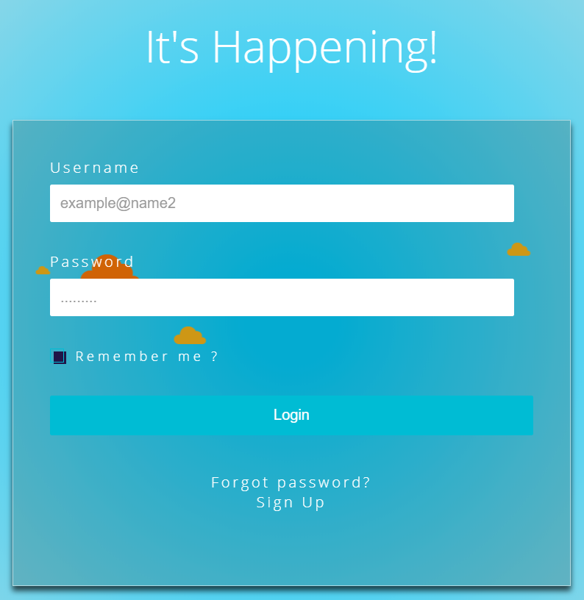

A new user should click on “Sign Up” option and will be redirected to the Registration page where he/she will be able to enter their details and credentials.

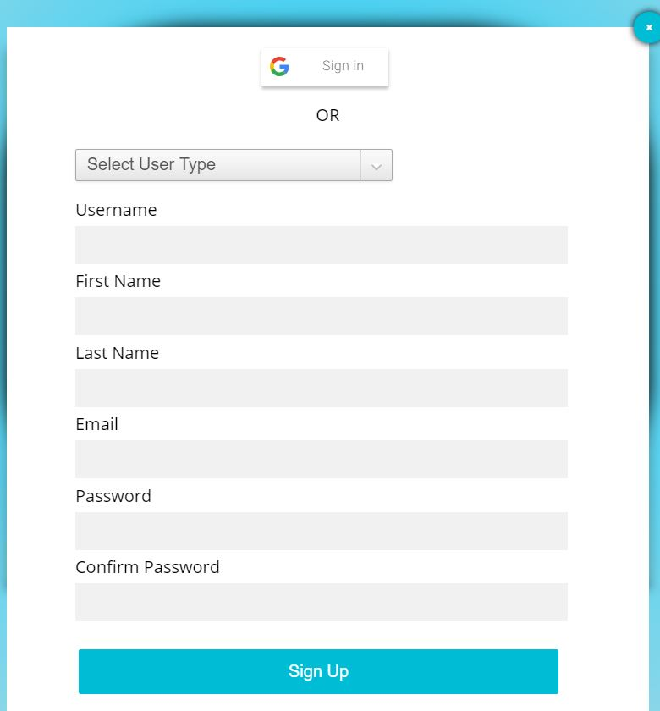

They will also need to chose the user type they are (Attendees who can buy tickets for any event with us or Organizers who can host different events with us.)

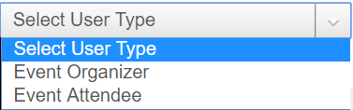

Users can also register with their GMAIL accounts:

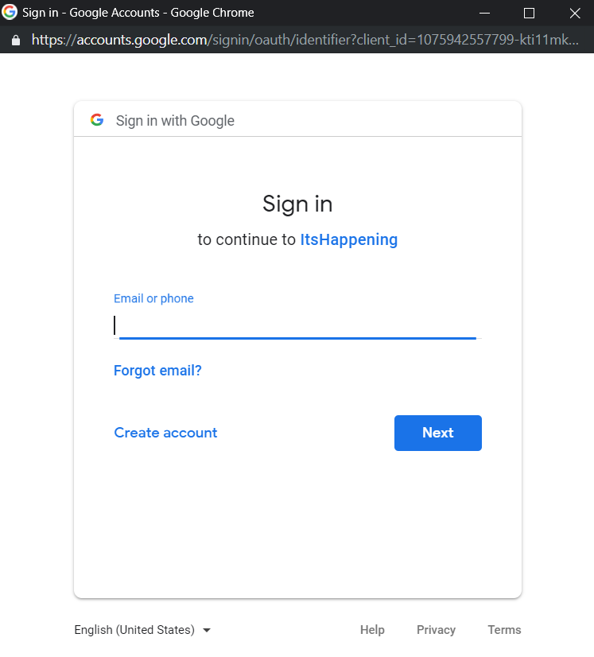

After logging in with the valid credentials, the user will be granted access to the website. Here, if the user has signed up as an ‘**Attendee**’ they will be redirected to the home page. If signed up as an ‘**Organizer**’, they will be redirected to the organizer dashboard page.

The Attendee will be able to view and explore the featured events on our banner, the upcoming events or search for events by keywords, date and categories on the home page.



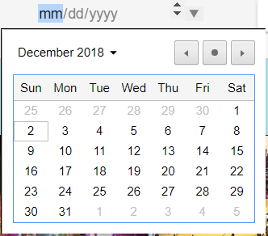 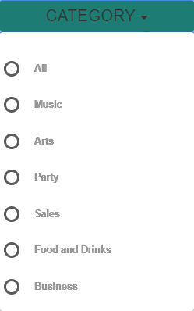

Upcoming events are displayed with information of event title, image, time and creator, ordered by the most recent event to the least.

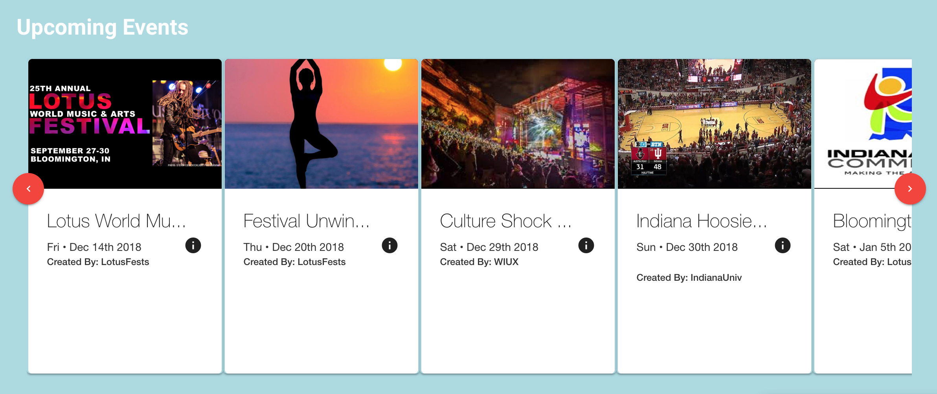

They can also view the events by category using the Category Cards (like the one below) which will redirect them to the browse page:

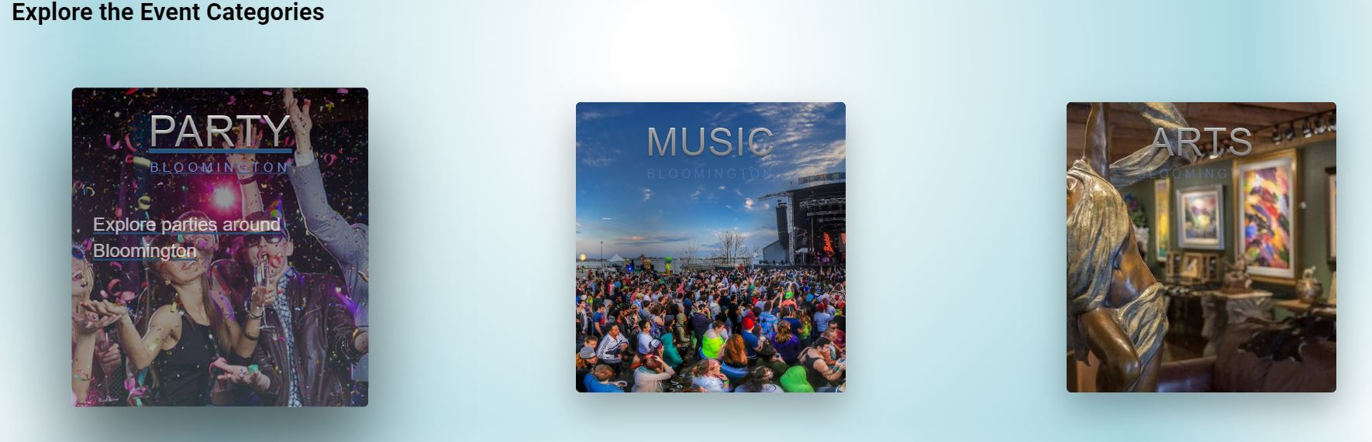

The browse page again lets us browse the events by categories and also shows us the location of the event on google maps.



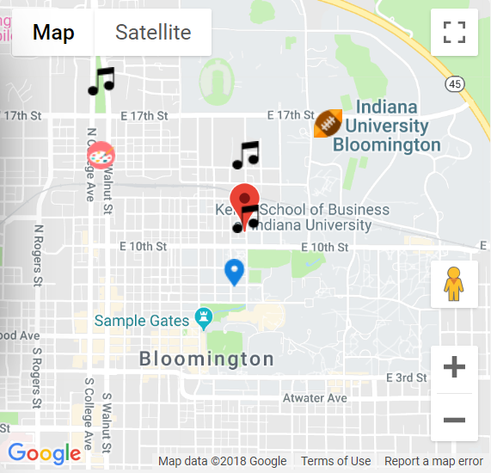

The Events card shows detailed information - title, author, descriptions, date, and image - of searched events.

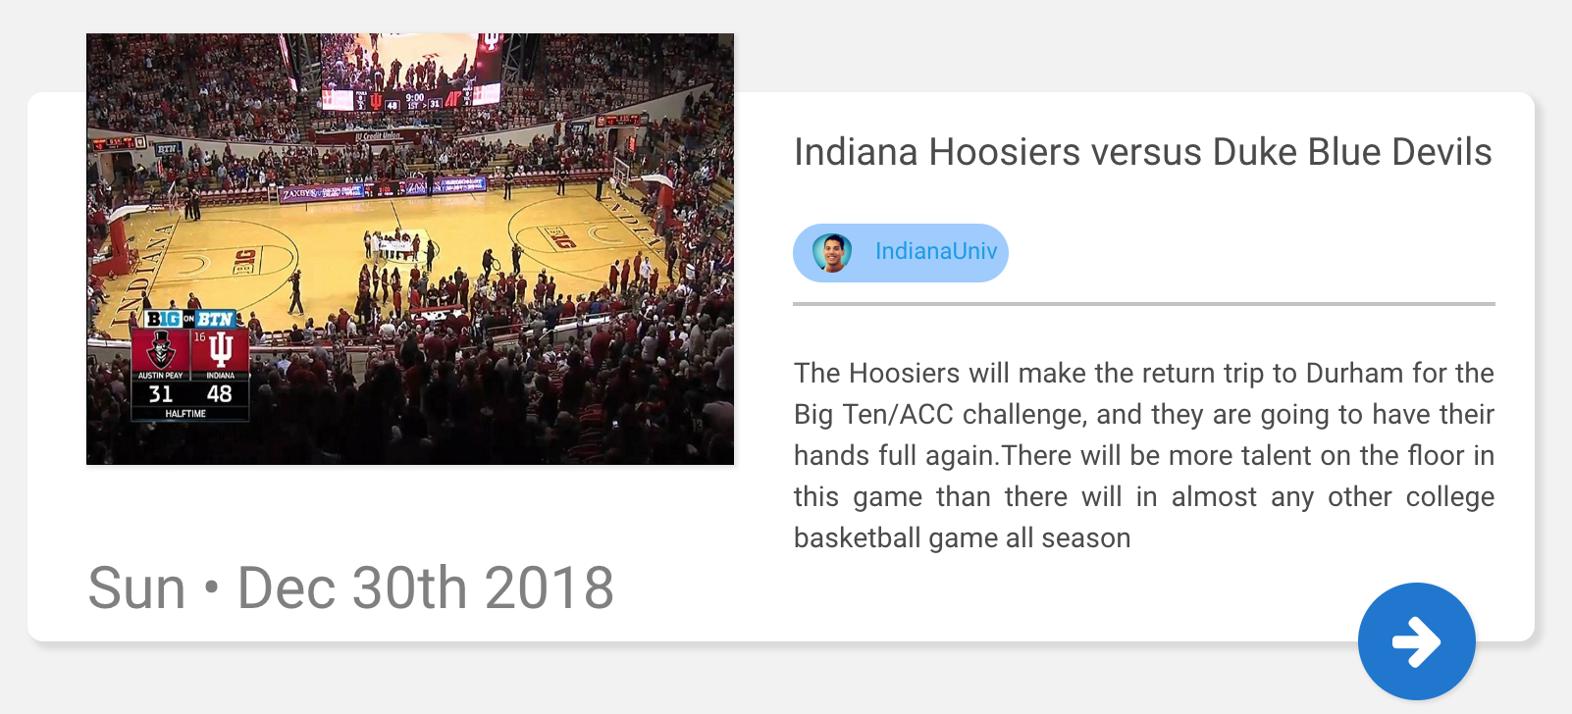

On clicking on the event of interest, the user will be redirected to the event’s page where they get the option of booking tickets:

Our browse page also features ads from organizations who will like to be featured on our site. Clicking on the ads will redirect user to the org’s site.



An organizer upon login will be redirected to his personalized dashboard wherein he can see real time statistics about the events he has hosted, his upcoming events and the monthly revenue details over the past year.

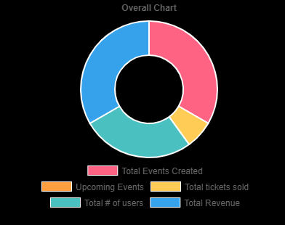

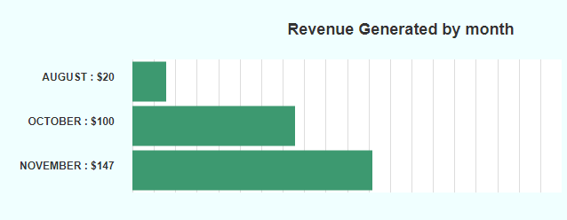



The organizer can also get the details per event like the number of tickets sold and the revenue made by clicking on the events listed under My events:

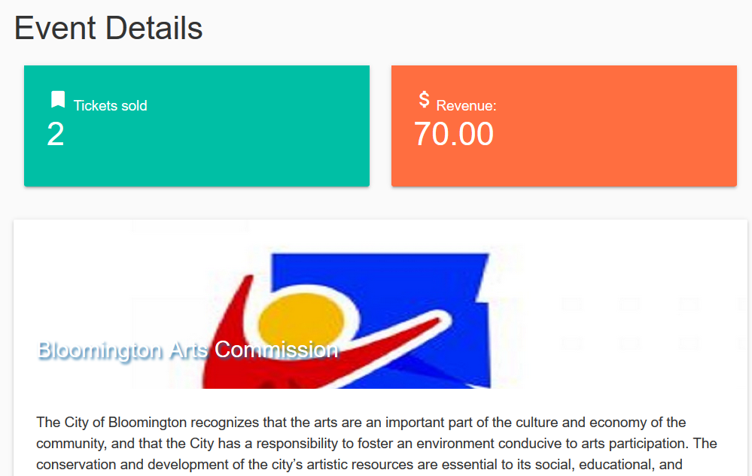

The organizer can create a new event from this dashboard page which will be sent to the admins of the site for review. The organizer can write some details about the event, the category of the event, date, venue, time and image. Additional information can be added by the organizer here but is optional.

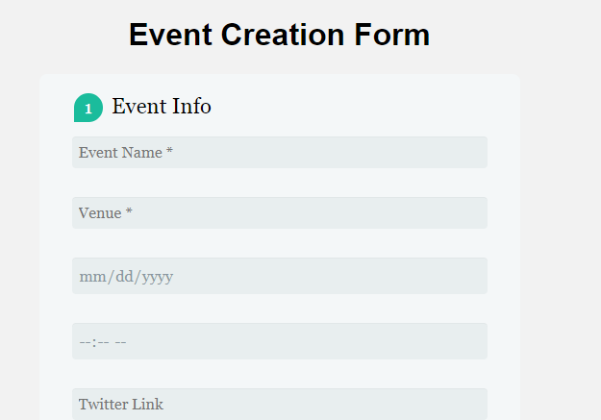

**Event Page and Book Tickets**

The payment has been implemented for 2 types of users:

1- Attendee

2- Organiser

**Attendee-** An user after login can select any event , which can be- featured events, upcoming events and can navigate to that particular event page which will be displayed as:

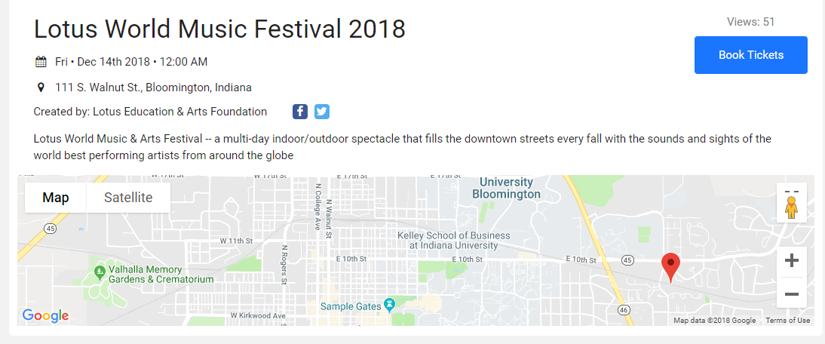

Here after clicking “Book Tickets” there will be a popup which will display the type of tickets, coupon code and a checkout, after which user will be able to pay via paypal.

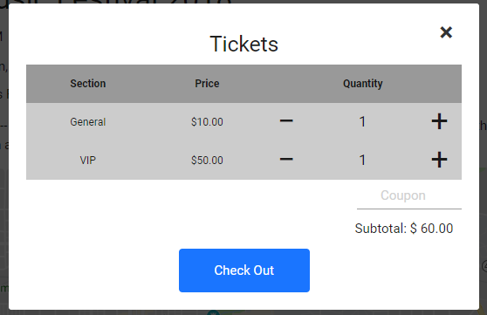

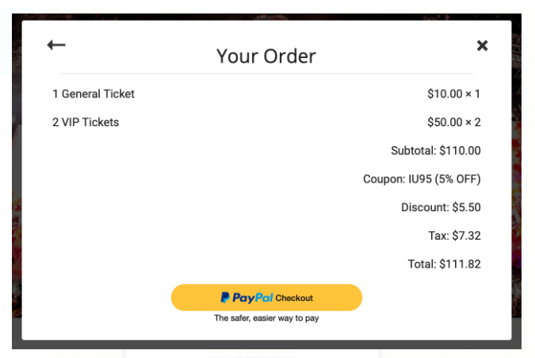

On the event page a user can also view the related event of that organiser and category.

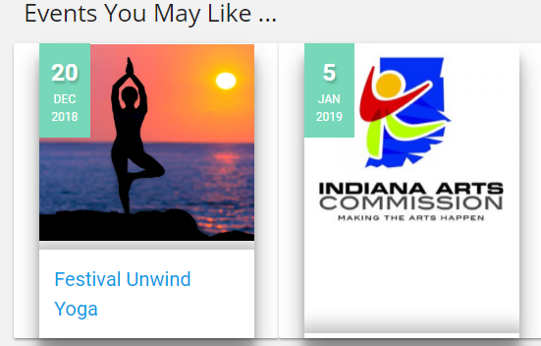

**Organiser -** For the organiser the payment is implemented while creation of event.

Currently he is charge flat 100$ for an event .



After clicking on this button organiser will be navigated to a popup with his order details and a button of paypal to initiate payment

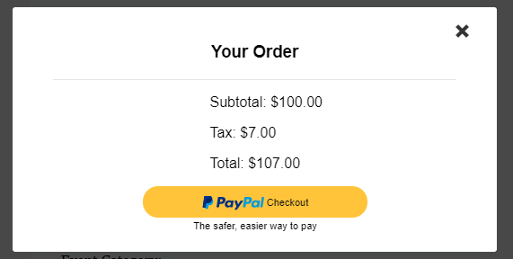

He can login into the paypal or can do a guest checkout :

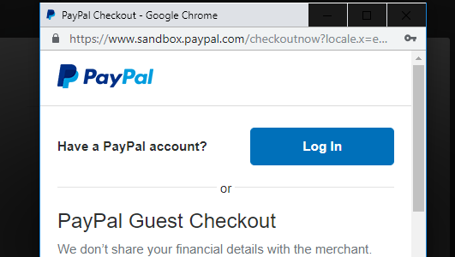

**Profile Page**

The profile page can be navigated via Menu bar and displays attendee with his information like - Full Name, Username, Email Id, Profile Picture.

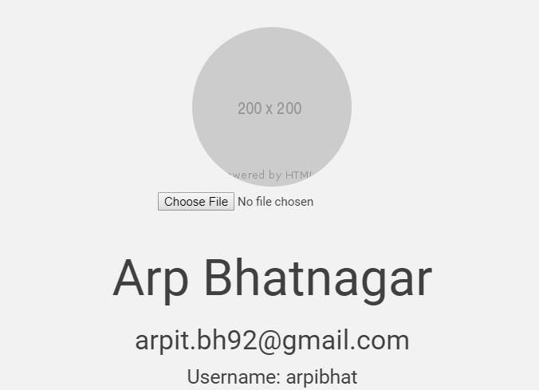

There are further 3 sections in the profile page which displays:

1- Edit Profile

2- Upcoming and Past Events

3- Statistics

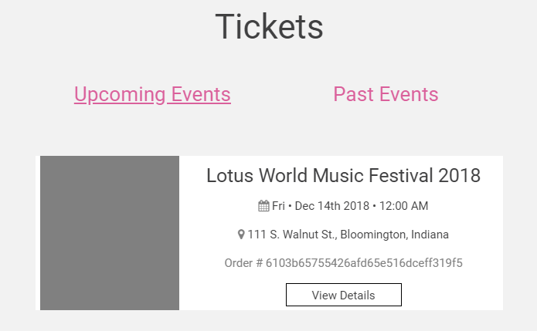

After clicking on View Tickets a user can see his ticket using QR code and can also book an Uber ride to the destination.

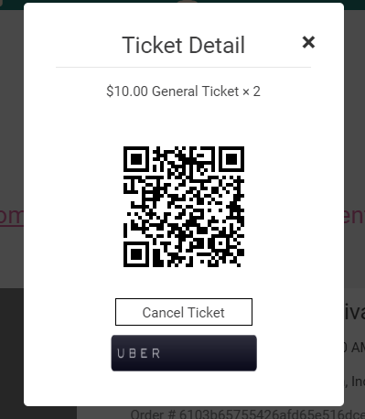

In the Edit profile a user will have to edit his information like- first name, last name, email, username

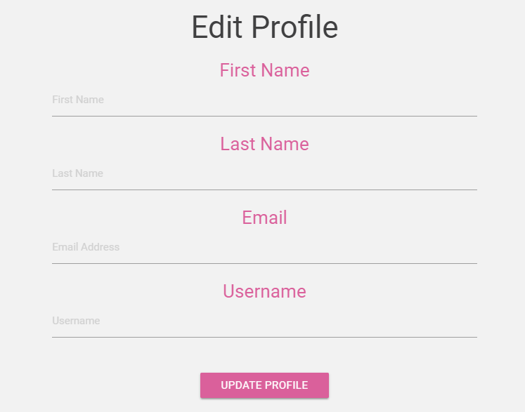

In the statistics part a user can view that how many events he has scheduled and the no of past events:

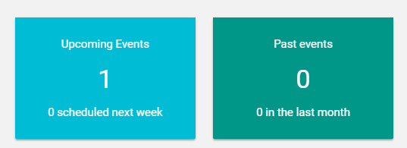

**Admin Page:**

On Admin login, admin can view the statistics

1. Number of user registered
2. Number of Organizer registered
3. Total revenue generated
4. Number of events created

And a graphical representation of revenue generated by month.

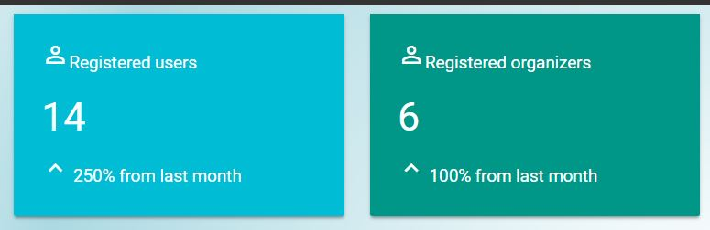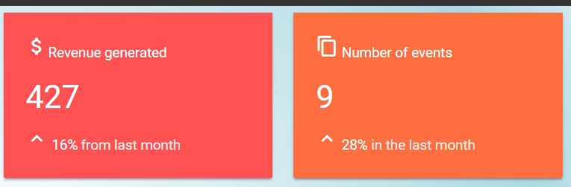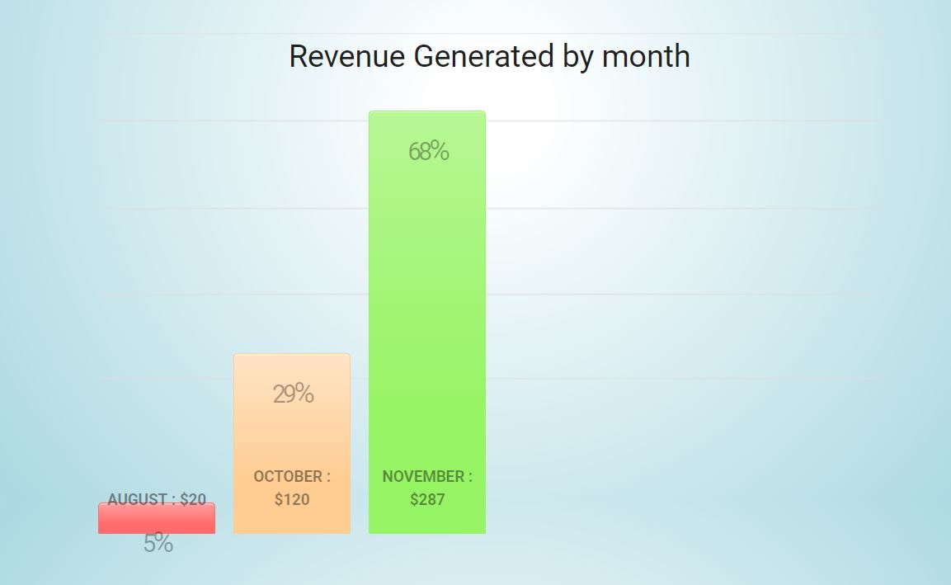

List of pending organizer and organizers approved is displayed on the dashboard

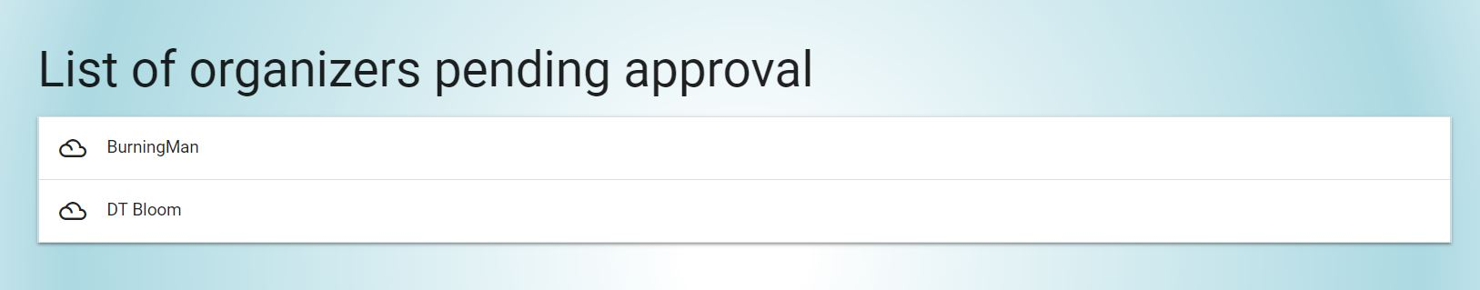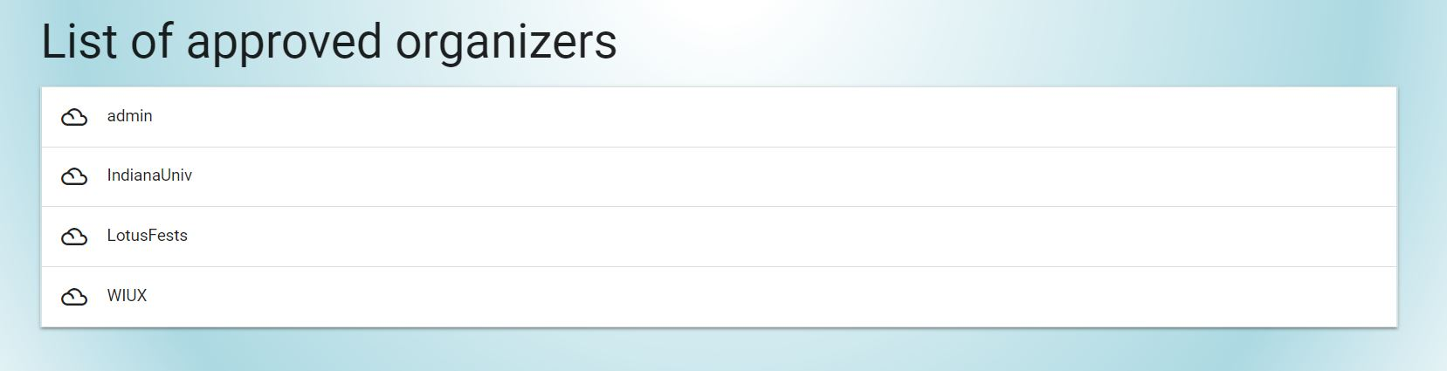

Upon clicking organizer row in pending / approved section, Admin can approve / reject an organizer.

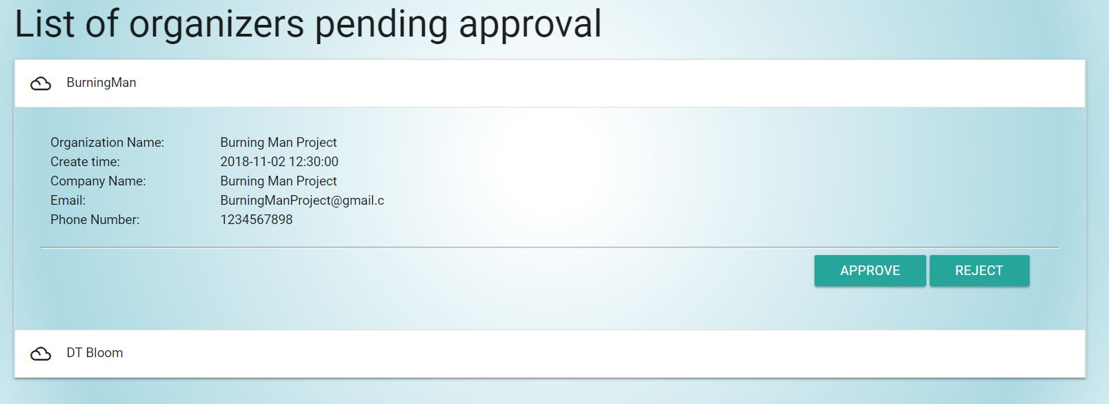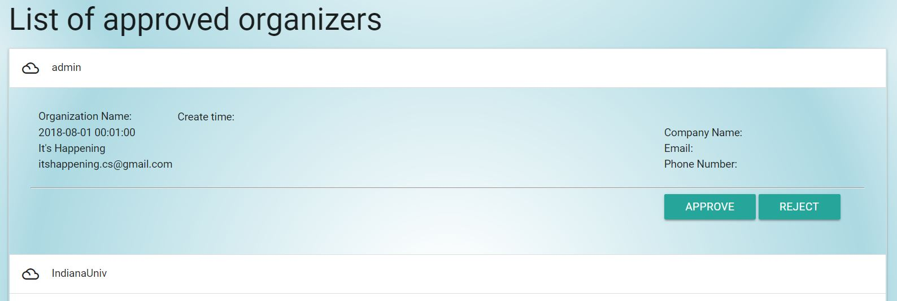

**About Us:**

This is visible when an user navigate to home page , he can see the name of the admins and the logo of the website , On clicking facebook link, it navigates to facebook page of the website.



**5. Known Defects**

Database connection and key storage insecure. Credentials for database are stored inside a php file in a utilities folder, may be subjected to information leaks.

Some backend information are sent through GET method instead of POST, may be subjected to information leaks.

**Revision History**

|  |  |  |
| --- | --- | --- |
| **Revision** | **Date** | **Change Description** |
| v1.0.0 | 12/02/2018 | Initial Version |
|  |  |  |
|  |  |  |
|  |  |  |
|  |  |  |
|  |  |  |
|  |  |  |
|  |  |  |
|  |  |  |